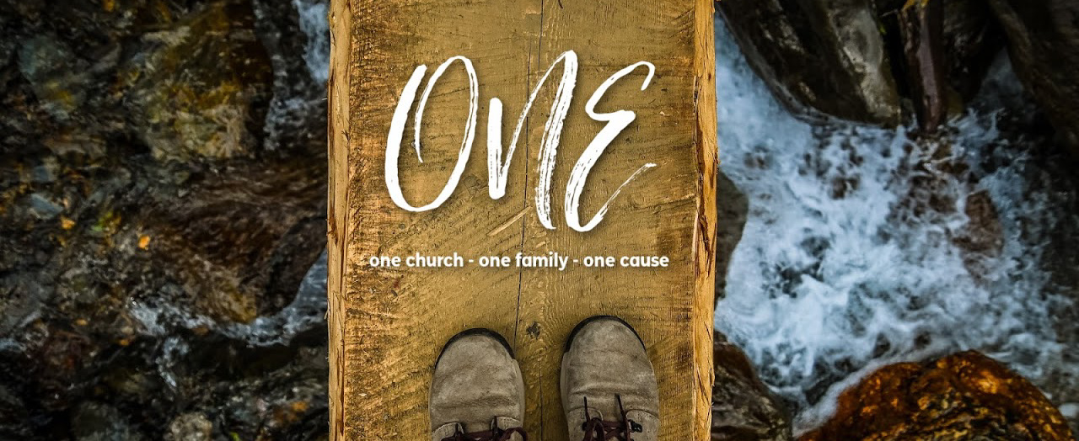

MESSAGE NOTES

5.9.21 | ONE, Part 3: Fear God

Live as people who are free, not using your freedom as a cover-up for evil, but living as servants of God. Honor everyone. Love the brotherhood. Fear God. Honor the emperor. 1 Peter 2:16-17 ESV

Now when all the people saw the thunder and the flashes of lightning and the sound of the trumpet and the mountain smoking, the people were afraid and trembled, and they stood far off and said to Moses, “You speak to us, and we will listen; but do not let God speak to us, lest we die.” Moses said to the people, “Do not fear, for God has come to test you, that the fear of him may be before you, that you may not sin.” EXODUS 20:18-20 ESV

__________________________ fear is a gift.

He gathers the waters of the sea as a heap; he puts the deeps in storehouses. Let all the earth fear the Lord ; let all the inhabitants of the world stand in awe of him! PSALM 33:7-8 ESV

Fear of God is best discerned by looking at it’s ____________________________.

BAD FEAR

  - A bad fear of God causes you to ______________________ God.
  - A bad fear of God causes you to _____________________.
  - A bad fear of God can be encouraged by ____________________________.

And Samuel said to the people, “Do not be afraid; you have done all this evil. Yet do not turn aside from following the Lord , but serve the Lord with all your heart. And do not turn aside after empty things that cannot profit or deliver, for they are empty. 1 SAMUEL 12:20-21 ESV

GOOD FEAR

Good fear _____________________________ God.

  - An ________________________ fear of God leads you to life change.
  - A proper fear of God is recognizing the majesty, power, and authority of God, resulting in a repugnance of evil and a desire to be and do good.
  - A good, abiding fear leads to _______________________________.

There is therefore now no condemnation for those who are in Christ Jesus. For the law of the Spirit of life has set you free in Christ Jesus from the law of sin and death. For God has done what the law, weakened by the flesh, could not do. By sending his own Son in the likeness of sinful flesh and for sin, he condemned sin in the flesh, in order that the righteous requirement of the law might be fulfilled in us, who walk not according to the flesh but according to the Spirit. ROMANS 8:1-4 ESV

And if you call on him as Father who judges impartially according to each one’s deeds, conduct yourselves with fear throughout the time of your exile… 1 PETER 1:17 ESV

Teach me your way, O Lord , that I may walk in your truth; unite my heart to fear your name.
PSALM 86:11 ESV

The fear of the Lord is the beginning of wisdom… PROVERBS 9:10a ESV

The fear of the Lord is a fountain of life… PROVERBS 14:27a ESV

I sought the Lord , and he answered me and delivered me from all my fears… Oh, taste and see that the Lord is good! Blessed is the man who takes refuge in him! Oh, fear the Lord , you his saints, for those who fear him have no lack! PSALM 34:4, 8-9 ESV

