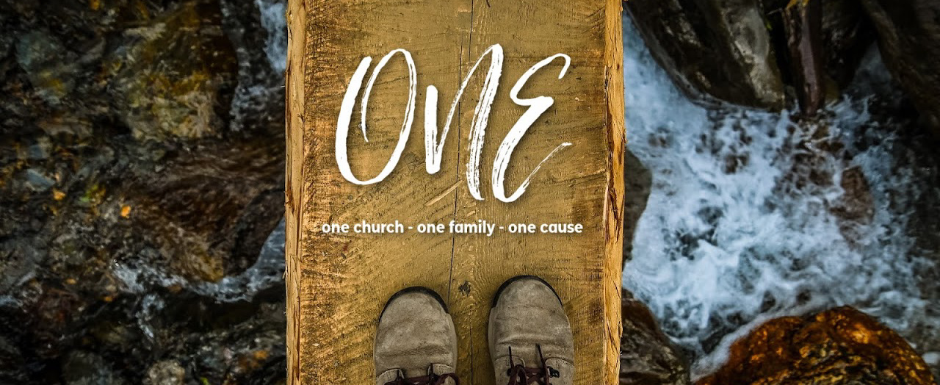

MESSAGE NOTES

4.25.21 | ONE, Part 2: Love God’s Family

Live as people who are free, not using your freedom as a cover-up for evil, but living as servants of God. Honor everyone. Love the brotherhood. Fear God. Honor the emperor. 1 Peter 2:16-17 ESV

THE BROTHERHOOD

________________ the brotherhood.
He’s talking about the _________________ — brothers and sisters in Christ.

THE WHY’S AND HOW’S OF LOVING EACH OTHER

Having purified your souls by your obedience to the truth for a sincere brotherly love, love one another earnestly from a pure heart, since you have been born again, not of perishable seed but of imperishable, through the living and abiding word of God… 1 Peter 1:22-23 ESV

- WHY? Because we are _________________________.

…knowing that you were ransomed from the futile ways inherited from your forefathers, not with perishable things such as silver or gold, but with the precious blood of Christ, like that of a lamb without blemish or spot. He was foreknown before the foundation of the world but was made manifest in the last times for the sake of you who through him are believers in God, who raised him from the dead and gave him glory, so that your faith and hope are in God. 1 Peter 1:18-21 ESV

  - To serve __________ is to love _________.
  - Our love is to be __________________________. From the Latin word, which means “without cracks”.

- HOW? We pursue the __________________________________.

  - Love one another ____________________________ and from a pure heart.
  - The Christian ___________________ for ways to love.

- WHY? Because we are family ________________________.
- HOW? We ______________________ the negative.

So put away all malice and all deceit and hypocrisy and envy and all slander. 1 Peter 2:1 ESV

- Malice is an intent to do __________________.
- Deceit is an intent to ________________________.
- I do not mess with _____________________________ or being fake.
- I uproot slander and __________________ — wanting what you have, and resenting you for having it.

- WHY? Because _________ are the _________________ that they meet God.

As you come to him, a living stone rejected by men but in the sight of God chosen and precious, you yourselves like living stones are being built up as a spiritual house, to be a holy priesthood, to offer spiritual sacrifices acceptable to God through Jesus Christ. 1 Peter 2:4-5 ESV

