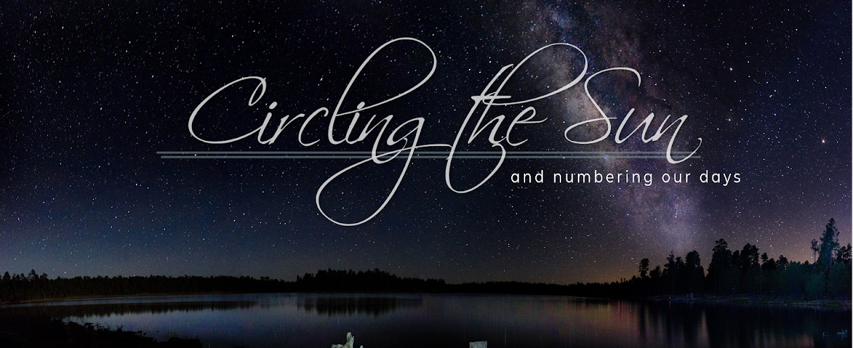

MESSAGE NOTES

1.31.21 | CIRCLING THE SUN, Part 4: Traveling Together

AGENTS OF CHANGE

Teach us to number our days, that we may gain a heart of wisdom. Psalms 90:12 NIV

- Is it possible that we could be agents of change, to bring more ________________ into the world?
  - If the answer to that question depended on me, would we be more divided or more unified?
- Humanity is fragile; we’ve got to ask God to make us ______________________________.
- There will always be tension in our journey. We can’t resolve that, but we can change our ______________.
- The enemy is the author of _______________________.
- Christ is the great ____________________.

Our reconciling “Peace” is Jesus! He has made Jew and non-Jew one in Christ . By dying as our sacrifice , he has broken down every wall of prejudice that separated us and has now made us equal through our union with Christ . Ethnic hatred has been dissolved by the crucifixion of his precious body on the cross. The legal code that stood condemning every one of us has now been repealed by his command . His triune essence has made peace between us by starting over—forming one new race of humanity, Jews and non-Jews fused together!

Two have now become one, and we live restored to God and reconciled in the body of Christ. Through his crucifixion, hatred died. For the Messiah has come to preach this sweet message of peace to you, the ones who were distant, and to those who are near. And now, because we are united to Christ, we both have equal and direct access in the realm of the Holy Spirit to come before the Father! Ephesians 2:14-18 TPT

You have all become true children of God by faith in Jesus the Anointed One! It was faith that immersed you into Jesus, the Anointed One, and now you are covered and clothed with his anointing. And we no longer see each other in our former state—Jew or non-Jew, rich or poor, male or female—because we’re all one through our union with Jesus Christ with no distinction between us. Galatians 3:26-28 TPT

Do not lie to one another, seeing that you have put off the old self with its practices and have put on the new self, which is being renewed in knowledge after the image of its creator.
Colossians 3:9-10 ESV

HAVE YOU PUT ON THE ____________ _________________?

- We have to start with human ____________________.

…all things were created through him and for him. Colossians 1:16 ESV
- We should seek to _________________________________.

The one who has knowledge uses words with restraint, and whoever has understanding is even-tempered. Even fools are thought wise if they keep silent, and discerning if they hold their tongues.
Proverbs 17:27-28 NIV

- Champion ________________________.

A soft answer turns away wrath… PROVERBS 15:1 ESV

- Persuade in _____________ and ________________________________.

By this all people will know that you are My disciples, if you have love for one another. John 13:35 ESV
…speaking the truth in love, we are to grow up in every way into him… Ephesians 4:15 ESV

- Work on your micro as if your micro was the __________________.

If it is possible, as far as it depends on you, live at peace with everyone. Romans 12:18 NIV

