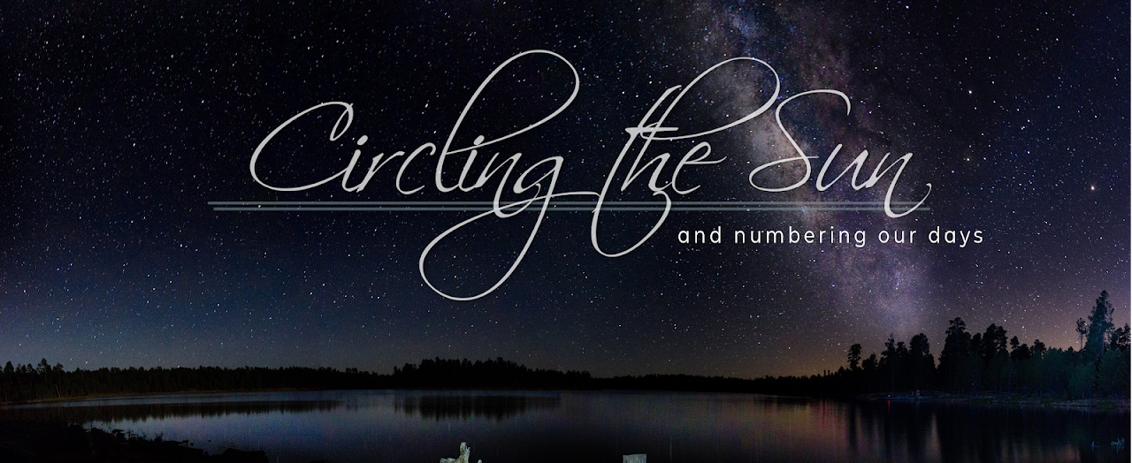

MESSAGE NOTES

1.10.21 | CIRCLING THE SUN, Part 2: Amazingly Small

BIG AND SMALL

The heavens declare the glory of God; the skies proclaim the work of his hands. Day after day they pour forth speech; night after night they reveal knowledge. They have no speech, they use no words; no sound is heard from them. Yet their voice goes out into all the earth, their words to the ends of the world… Psalms 19:1-4 NIV

PSALMS 90

The _______________________ of God.

The _______________________ of man.

Lord, you have been our dwelling place throughout all generations. Before the mountains were born or you brought forth the whole world, from everlasting to everlasting you are God.

You turn people back to dust, saying, “Return to dust, you mortals.” A thousand years in your sight are like a day that has just gone by, or like a watch in the night. Yet you sweep people away in the sleep of death— they are like the new grass of the morning: In the morning it springs up new, but by evening it is dry and withered.

We are consumed by your anger and terrified by your indignation. You have set our iniquities before you, our secret sins in the light of your presence. All our days pass away under your wrath; we finish our years with a moan. Our days may come to seventy years, or eighty, if our strength endures; yet the best of them are but trouble and sorrow, for they quickly pass, and we fly away. If only we knew the power of your anger! Your wrath is as great as the fear that is your due. Teach us to number our days, that we may gain a heart of wisdom.

Relent, Lord ! How long will it be? Have compassion on your servants. Satisfy us in the morning with your unfailing love, that we may sing for joy and be glad all our days. Make us glad for as many days as you have afflicted us, for as many years as we have seen trouble. May your deeds be shown to your servants, your splendor to their children.

May the favor of the Lord our God rest on us; establish the work of our hands for us— yes, establish the work of our hands. Psalms 90:1-17 NIV

WHAT HIS GRANDEUR MEANS FOR US

The most freeing thing God can give to you is the gift of His ________________________. It will allow you, in some way to offload the weight of thinking that life is all about ____________.

We can have ______________________________ in our big God.

TAKE IT HOME

CHALLENGE 1. Pray: “I need a heart of wisdom, God, to be saved from the ordinary — and be awakened, again, into the wonder of who You are! And I need a heart of wisdom to know the fact that a God as great as You created me, to know You and to walk with You.”

CHALLENGE 2. That our 2021-year would have the banner over it that would say: “________________________ with God.”

